Cover sheet for submission of
work for assessment

UNIT DETAILS
Unit name |  | Data Science Principles |  |  |  |  |  | Class day/time | Monday | ^{Office use only}
Unit code |  | COS10022 |  |  | Assignment no. |  | 1 | Due date | 6 Oct at 17:59
Name of lecturer/teacher |  |  |  | Dr. Mai Duc Tho
Tutor/marker’s name |  |  | Dr. Mai Duc Tho |  |  |  |  |  |  | _{Faculty or school date stamp}
STUDENT
ZFamily Name(s) |  |  |  |  |  | Given Name(s) |  |  |  | Student ID Number(s)
 | Nguyen |  |  |  |  | Dinh Phu |  |  |  | 105027282

DECLARATION AND STATEMENT OF AUTHORSHIP
- I/we have not impersonated, or allowed myself/ourselves to be impersonated by any person for the purposes of this assessment.
- This assessment is my/our original work and no part of it has been copied from any other source except where due acknowledgement is made.
- No part of this assessment has been written for me/us by any other person except where such collaboration has been authorised by the lecturer/teacher concerned.
- I/we have not previously submitted this work for this or any other course/unit.
- I/we give permission for my/our assessment response to be reproduced, communicated, compared and archived for plagiarism detection, benchmarking or educational purposes.
I/we understand that:
- Plagiarism is the presentation of the work, idea or creation of another person as though it is your own. It is a form of cheating and is a very serious academic offence that may lead to exclusion from the University. Plagiarised material can be drawn from, and presented in, written, graphic and visual form, including electronic data and oral presentations. Plagiarism occurs when the origin of the material used is not appropriately cited.
Student signature/s
I/we declare that I/we have read and understood the declaration and statement of authorship.



Swinburne University of Technology Hawthorn Campus
Dept. of Computing Technologies

COS10022 Data Science Principles
Assignment 1 - Semester 1, 2024

Assessment Title: Predictive Model Creation and Evaluation

Assessment Weighting: 20%
Due Date: Sunday, 24th March 2024 at 11.59 pm (AEDT)
Assessable Item:
- One (1) piece of a written report no more than 10-page long with the signed Assignment Cover Sheet.
- The submitted report must be checked by Turnitin, and the similarity from not the template part should be less than 12%.

The submitted report should answer all questions listed in the assignment task section in sequence.
You must include a digitally signed Assignment Cover Sheet with your submission.

Data Preparation (10%)

  - Data preparation for training and test set:
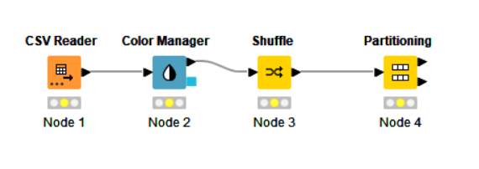
- For data preparation, we used four essential nodes: CSV Reader, Color Manager, Shuffle, and Partitioning. The CSV Reader was employed to load data from the file "Fish_Species.csv," containing 150 tuples and 6 attributes:“Weight_of_Fish_in_Gram,”“Diagonal_Length_in_cm,”,“Vertical_Length_in_cm,” “Cross_Length_in_cm,” “Height_in_cm,” and ”Diagonal_Width_in_cm.” The Color Manager was used to assign colors to different species, aiding data visualization and information recall. To eliminate potential bias during training, the Shuffle node was applied with a seed value of 9214 for reprehensibility. Lastly, the Partitioning node split the dataset into 80% for training and 20% for testing using the “draw randomly” method, again with the same seed value of 9214. The training set contains 120 tuples, while the test set includes 30 tuples.
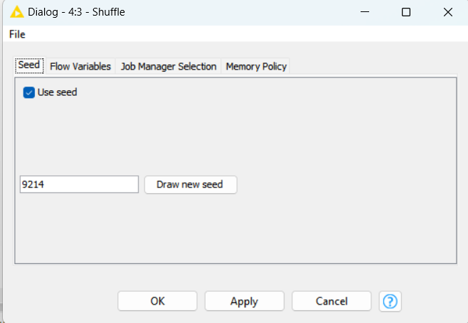
- By applying the Shuffle Node, the data is randomized to reduce any potential sampling bias that could affect the algorithm's performance. The dataset is shuffled using the seed value of 9214 to ensure consistent and reproducible results. Shuffling the data before partitioning ensures that both the training and test sets contain a diverse representation of the data, which helps improve the model's ability to generalize.

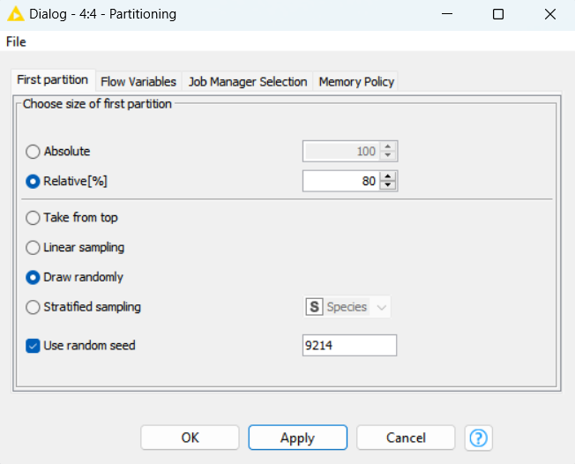

- Following the data shuffling process, the Partitioning Node is utilized to split the dataset into 80% for training and 20% for testing. This ensures that the training and test sets are distinct from each other. The partitioning is done using the "draw randomly" method with a seed value of 9214 to maintain consistency and reproducibility. The training set is then used to build and train the model, which is later evaluated on the test set to predict its output values.

- Answering the assignment questions:

  - Submit the workflow of Assignment 1 via Assignment 1.1. [2.5 marks]

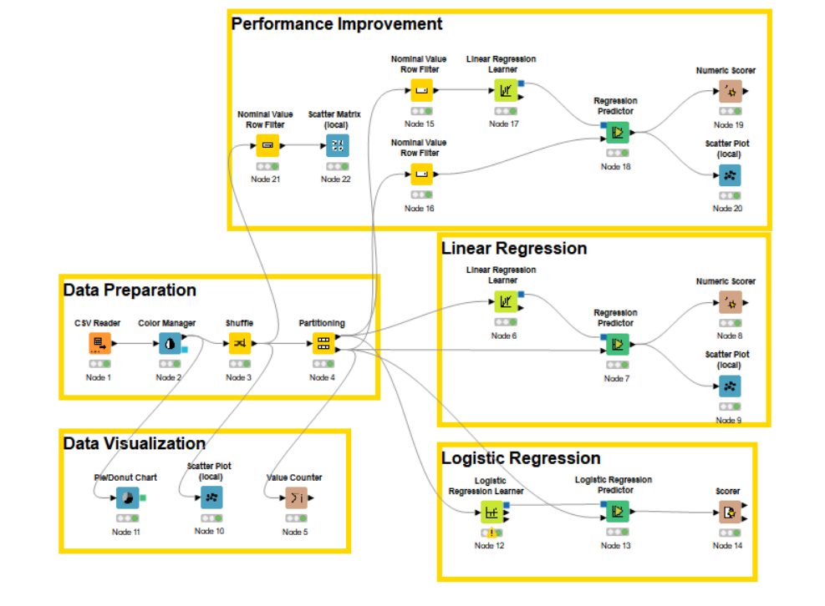
Answer:

  - How many tuples are included in the training set? [2.5 marks]
Answer: 120 tuples
Explain: The total number of tuples is 150 and Training set is 80% so: 150× 80% = 120 tuples

  - How many species are included in the test set? [2.5 marks]

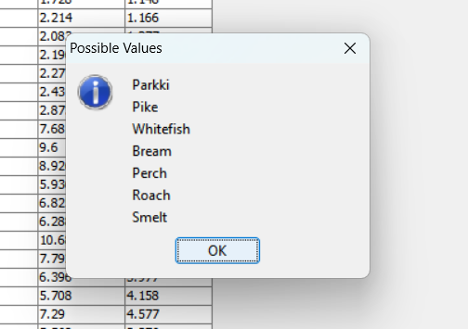

Answer: There are 7 species in the test set including “Parkki”, “Pike”, “Whitefish”, “Bream”, “Perch”, “Roach”, and “Smelt”.

  - Do species “Whitefish” and “Smelt” have the same number of tuples included in the test set?
[2.5 marks]
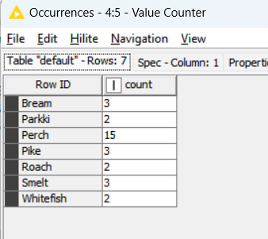

Answer: NO. By using the Value Counter Node, we can see that the number of tuples for two species “Whitefish” and “Smelt” are not the same. “Smelt” has 3 tuples while “Whitefish” has only 2 tuples

Linear Regression (40%)

- Linear Regression Model building :

To successfully build a Linear Regression Model for predicting the weight of the fish, I divided it to 3 small steps:

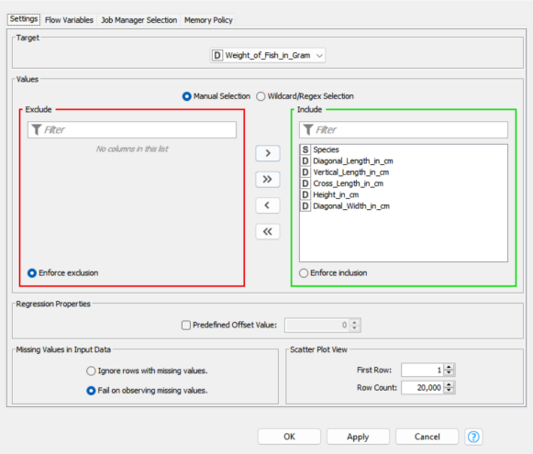
1. Building the Linear Regression Model:
- Add the Linear Regression Learner node:
  - Connect the output from the Partitioning node's training set to this node
  - Set the target column as "Weight_of_Fish_in_Gram"
  - Make use of all possible attributes for training the model
  - Execute the node to train the linear regression model

2. Predicting on Test Set:
- Add the Linear Regression Predictor node (this node is used for data predicting) :
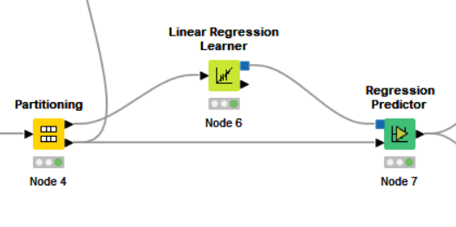
  - Connect the testing data partition and the trained model in the previous step to this node.
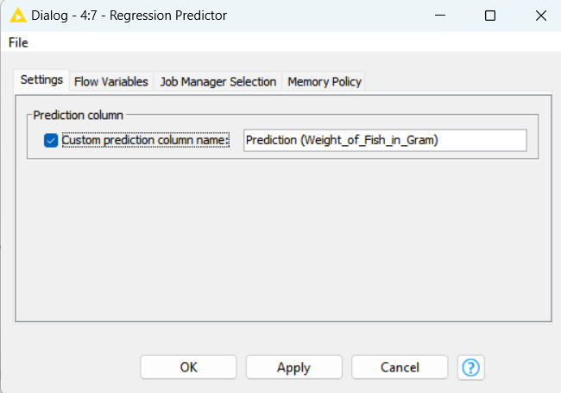

  - Configuration: Select the Prediction Column and the model will predict the weight of the fish on the test data.

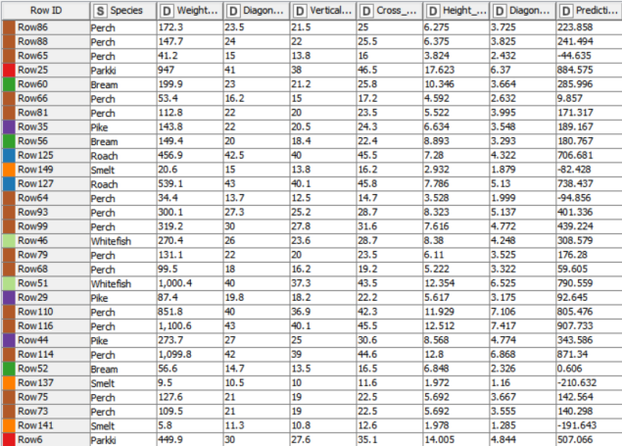

  - Execute the node to get predictions for "Weight_of_Fish_in_Gram"

3. Evaluating the Model and Visualizing the Results:
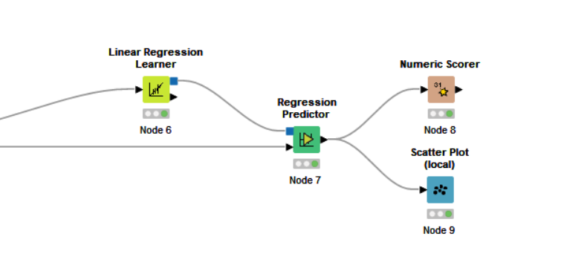
- Add Numeric Scorer and Scatter Plot nodes:
  - These nodes are used for evaluation and visualization by comparing predicted weights with the actual weights in the test set
  - Connect the output of the Linear Regression Predictor node to these nodes

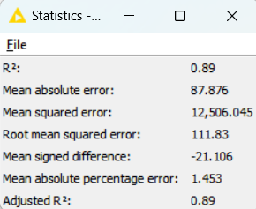
- Answering the assignment questions:

- What is the $R^{2}$ value of your test result? [5 marks]
Answer: 0.89
Explain: We utilized the Numeric Scorer node to evaluate the performance of our linear regression model, which generated several statistical measures, including R², MSE, MAE, RMSE, MSD, MAPE, and Adjusted R².

- Give the screenshot of the scatter plot result of your test output using “Weight_of_Fish_in_Gram” on the x-axis and the prediction value on the y-axis. Assign different colours to the data points based on the “species.” [15 marks]
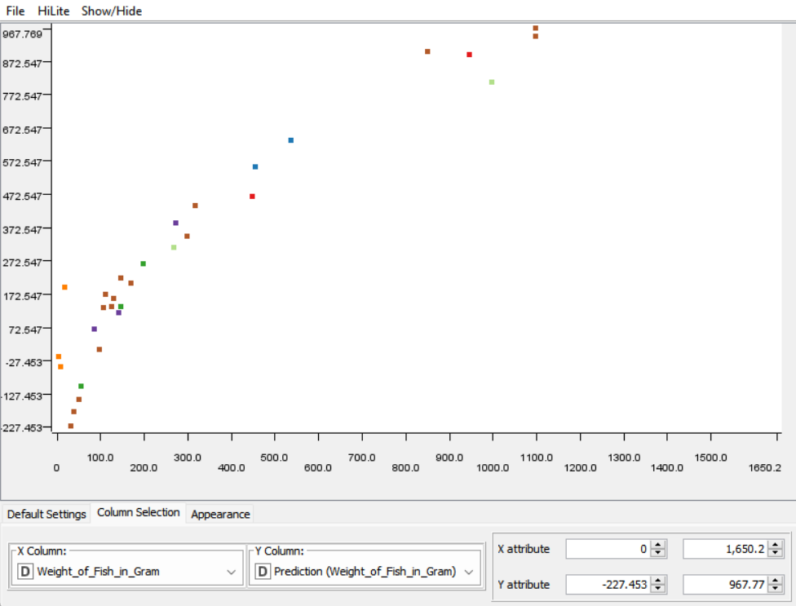

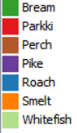

- Which species has the heaviest predicted weight in your test result? [5 marks]
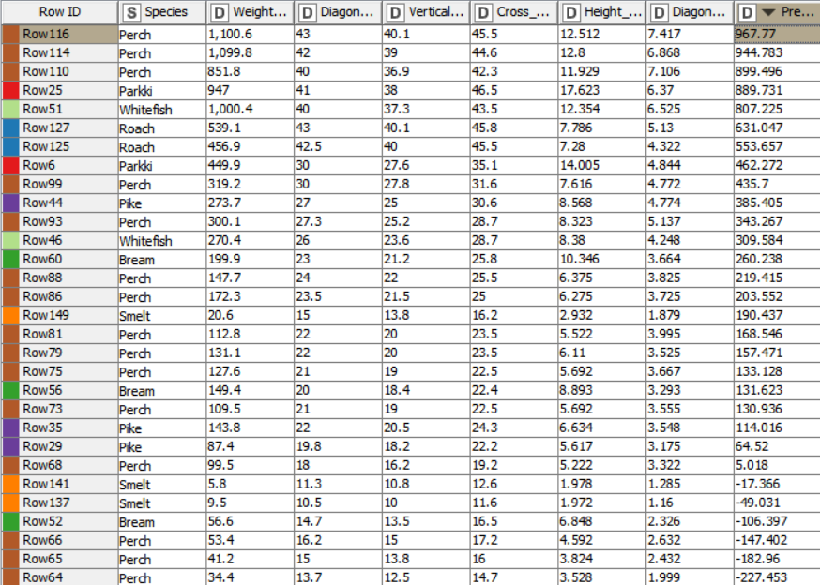
Answer: Perch
Explain: According to the predicted data table we can clearly see that “Perch” has the highest predicted number of 967.77

- How many prediction results are infeasible in your test result? [5 marks]

Answer: 6
Explain: In the right-bottom of the table, there are 6 predicted weights which are negative number. These are definitely infeasible results because “Weight_of_Fish_in_Gram” must be a positive number

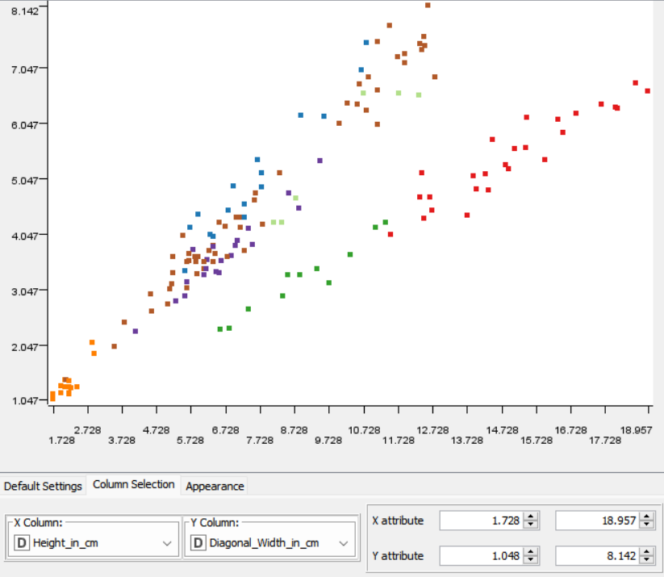
- Looking at your source data before splitting them, which species can be easily separated from others if looking at the “Height_in_cm” and “Diagonal_Width_in_cm” attributes? Post your visualisation result on data observation in the report. [5 marks]
Answer: Smelt and Parkki



- Draw a doughnut chart of the original input data with 0.55 as the doughnut hole ratio before splitting it into training and test sets. Use different colours for each species and show the percentage of data in the pie chart. [5 marks
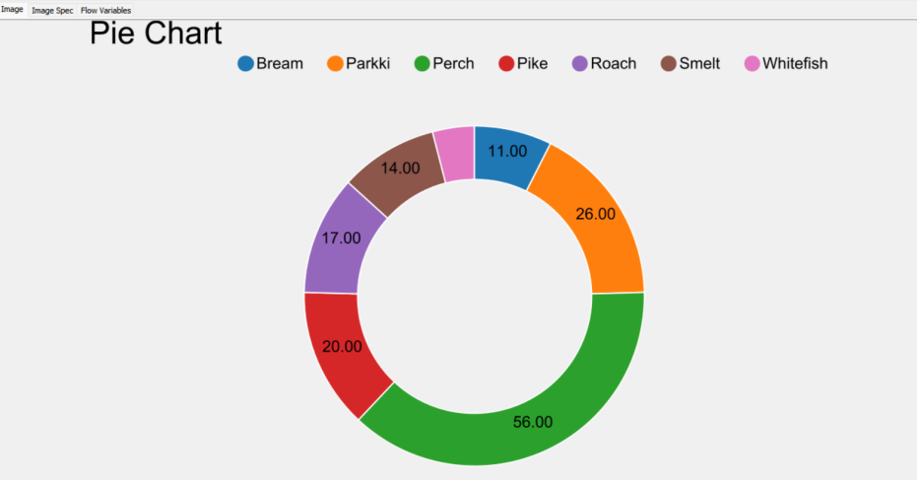
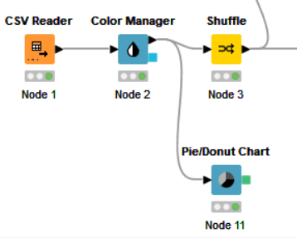
On this task, I included a Pie/Donut Chart node to draw a doughnut chart of the original input data from the CSV file with 0.55 hole ratio with various colors for each species:

Logistic Regression (40%)

- Logistic regression model building :
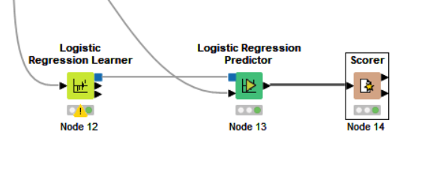
Logistic regression model includes a
Logistic Regression Learner node, a Logistic
Regression Predictor node and Scorer node .
.I used Smelt as a reference category and the termination points of epochs and epsilon
are limited to 10.000 and 0.00001 respectively, use “LineSearch” as the learning rate strategy. Use 9214 as the seed in the logistic regression node

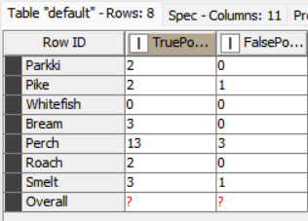
- Answering the assignment questions:
- Which species have/has no “True Positive (TP)” case in the prediction result? [5 marks]
Answer: Whitefish

- For the species with no TP case, which species will be misplaced? [5 marks]
Answer: Perch
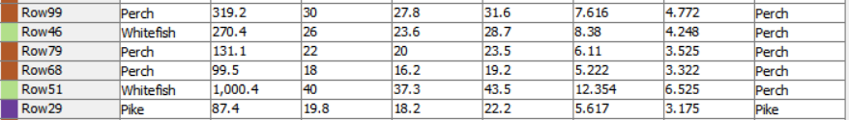

- What is the overall accuracy of the prediction result? [5 marks]
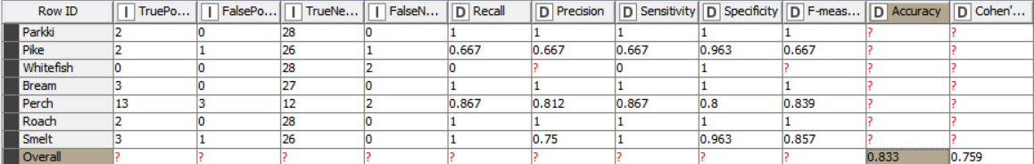
Answer: 0.833

- List all species names with 100% correctly classified test results. [15 marks]
Answer: Parkki, Bream, Roach
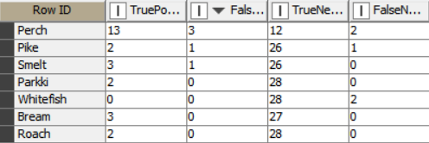
Explain: Based on the below formula to calculate each species name and 3 above species have the results equal 1 (100% accuracy).
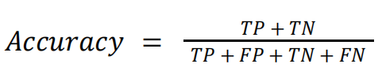

- Which species has a 33.33% chance of being misplaced into another species in the test result? [5 marks]
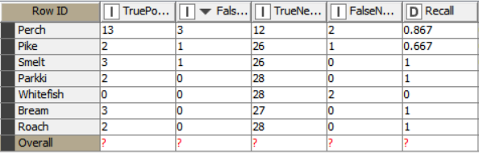
Answer: Pike
Explain: FNR = 1 − Sensitivity/Recall
= 1 − 0,667
= 0.333 ( = 33.33%)

- In the test result, what percentage of the species “Perch” is misplaced into others? [5 marks]

Answer: 13.3 %
Explain: The percentage of the species “Perch” which are misplaced into others is the percentage of species “Perch” is classified incorrectly to another species name . We have the same formula:
FNR = 1 – Sensitivity/Recall
= 1 – 0.867
= 0.133 ( = 13.3 %)

Performance Improvement (10%) :

- Build a new linear regression mode:
The goal of this task is to build a more accurate linear regression model, focusing specifically on predicting the weight of the fish species “Perch.” By improving the model's accuracy, we aim to achieve a higher R² value compared to the previous model.
To concentrate solely on the “Perch” species, two Nominal Value Row Filter nodes is used to filter the data, ensuring that only the relevant tuples containing “Perch” are included in both the training and test sets. This filtering process occurs after partitioning the shuffled input data, ensuring that the resulting subsets remain part of the original training and test sets used in earlier stages of the assignment.
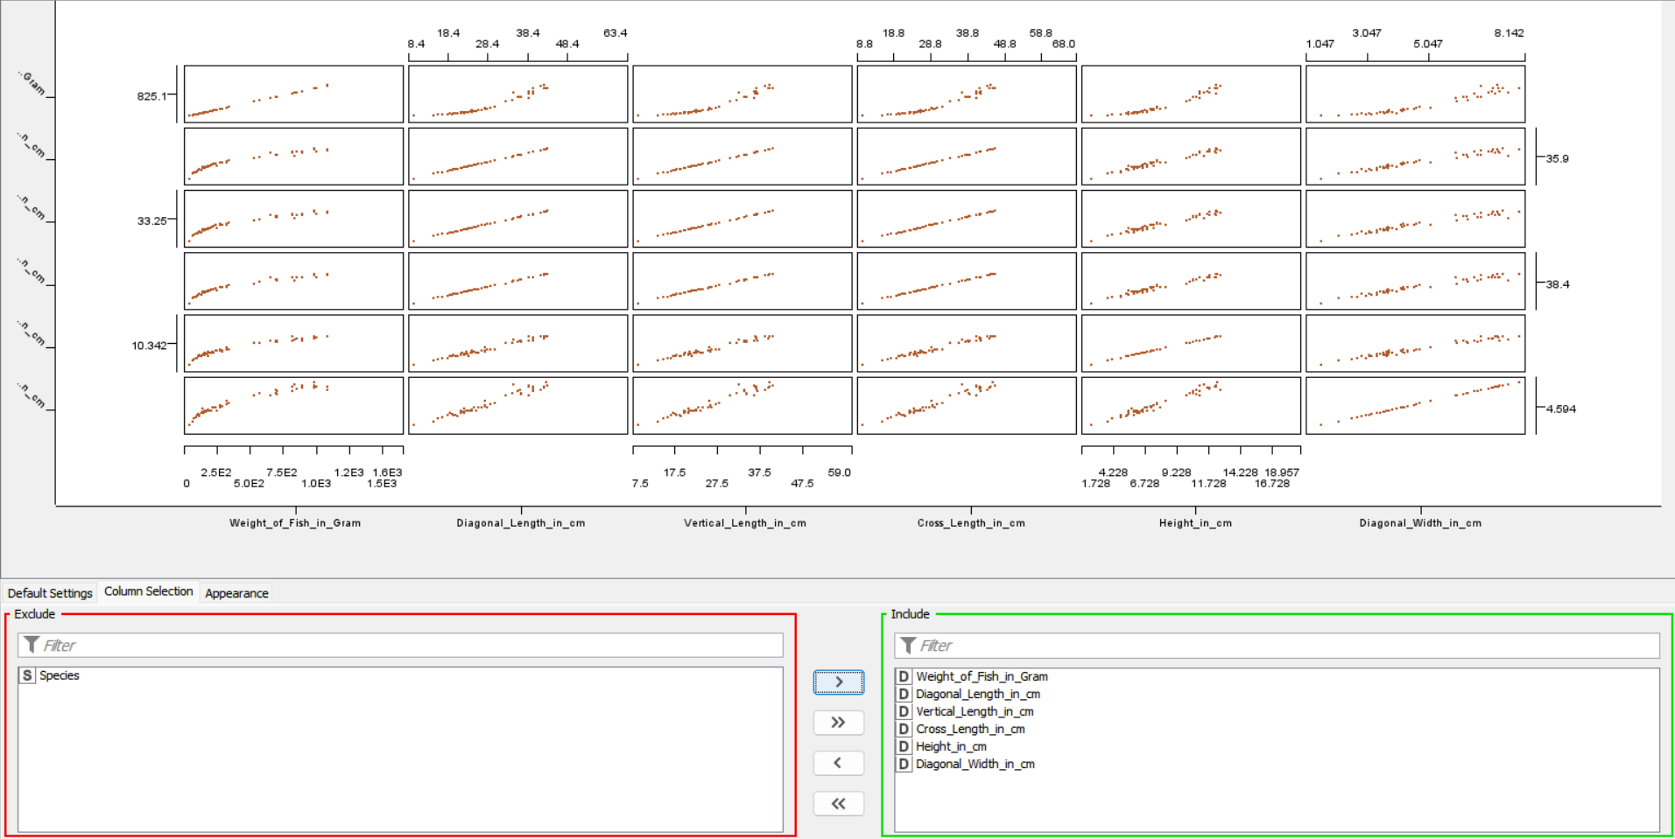
I am limited to using three attributes from the available five, which necessitates the removal of two attributes. To facilitate this decision, the Scatter Matrix (local) node is employed, enabling us to visually assess the relationships between the input attributes and choose the most suitable ones for the model.

- Answering the assignment questions:

- Give the reasons for each eliminated attribute and why they are not selected as the input. [5 marks]
Answer: Based on the data from the Scatter Matrix node, two attributes are: "Diagonal_Width_in_cm" and "Weight_of_Fish_in_Gram"
Reasons:
- Eliminate "Diagonal_Width_in_cm" because it shows a weaker linear relationship with "Weight_of_Fish_in_Gram" compared to other variables. Including it may introduce noise rather than valuable information, and it could also contribute to multicollinearity, as it is highly correlated with other length measurements.
- Eliminate "Height_in_cm" because it exhibits a weaker linear relationship with "Weight_of_Fish_in_Gram" compared to other attributes. Its correlation with weight is less pronounced, which can introduce noise and reduce the model's predictive accuracy. Additionally, keeping this variable may lead to multicollinearity issues, as it is likely correlated with other length measurements.
These eliminations will improve the overall accuracy and stability of the regression model.

- List the $R^{2}$ of your test result and compare it with the one in question 2. Reveal both $R^{2}$ values obtained in question 2 and in question 4. If you can improve the model, you get the mark. [5 marks]
Answer:


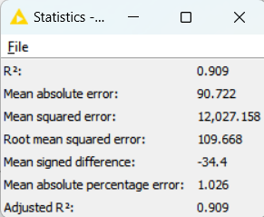
First model Improved model

A higher R² value indicates improved accuracy in prediction results, and in this case, the model's accuracy has increased by 0.1. This enhancement demonstrates that removing unsuitable attributes to reduce the dimensionality of the input data contributes significantly to the model's overall predictive accuracy.

Conclusion :

The assignment successfully achieved its goals of analyzing data and developing predictive and classification models. A linear regression model was created to predict fish weight, while a logistic regression model was used for classifying fish species. By refining the linear regression model to focus solely on one species and utilizing only three relevant attributes, the accuracy of predictions improved significantly through the removal of two unsuitable attributes. This process not only enhanced the model's performance but also provided me with valuable skills in data preparation, model analysis, evaluation, and optimization.

